**INTRODUCTION**

**OVERVIEW:**

An applicant tracking system (ATS) is software for recruiters and employers to track candidates throughout the recruiting and hiring process. This software can come equipped with capabilities ranging from simple database functionality to a full-service suite of tools that makes it easy for businesses of any size to filter, manage, and analyze candidates.

|  |
| --- |
|  |

**PURPOSE:USES**

Every organization is unique, but each one thrives on attracting, hiring, and maximizing top talent. Many businesses face major challenges at some point in the hiring or onboarding process. An [ATS can offer a variety of capabilities](https://blogs.oracle.com/oraclehcm/post/why-you-should-use-an-applicant-tracking-system" \t "https://www.oracle.com/in/human-capital-management/recruiting/what-is-applicant-tracking-system/_blank) that can help the organization find, hire, and retain the best candidates

ACHIEVED:

**Best practices for getting your resume through an applicant tracking system**

1

Only apply for jobs you qualify for.

2

Be selective about the jobs you apply for at one company.

3

Use relevant keywords.

4

Connect your keywords to unique experiences.

5

Include a skills section.

6

Use basic language.

7

Write out acronyms.

**PROBLEM DEFINITION & DESIGN THINKING:**

**EMPATHY MAP:**

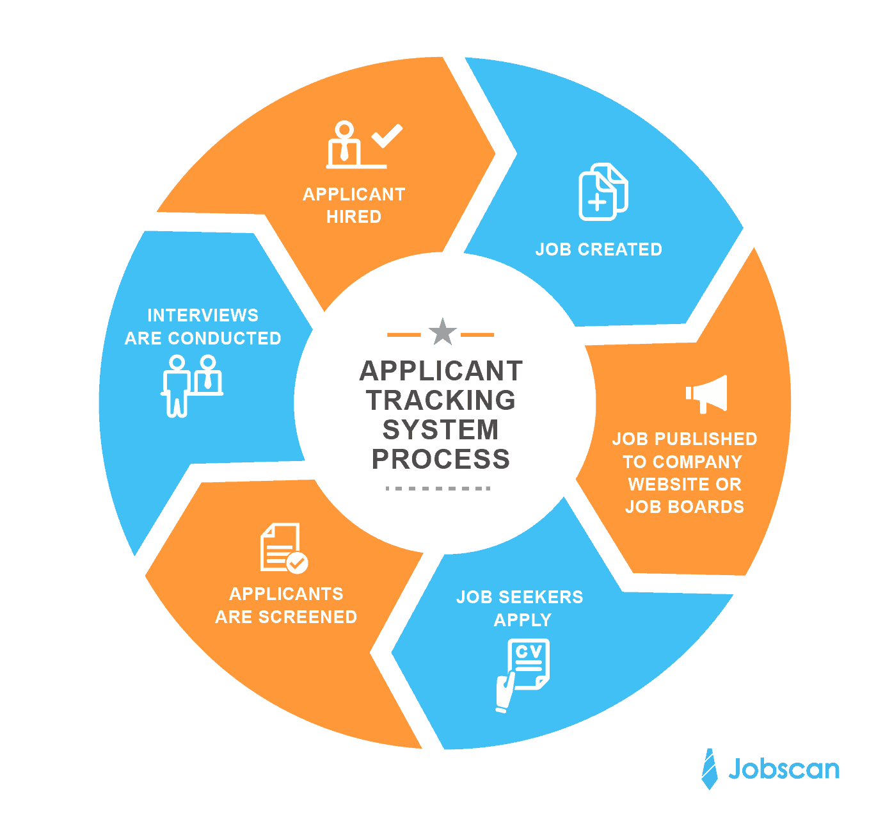

IDEATION & BTAINSTORMING MAP:

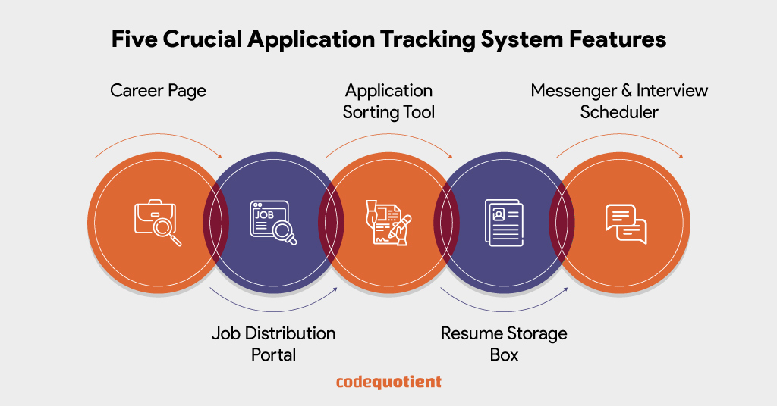

# RESULT:

|  |
| --- |
|  |
|  |
|  |
|  |
|  |
|  |
|  |
|  |
|  |

DATA MODEL:

|  |  |
| --- | --- |
| Object name | Fields in the object |
| Obj1 | |  |  | | --- | --- | | Field label | Data type | | Created by | Lookup(user) | | Last modified by | Lookup(user) | |
| Obj2 | |  |  | | --- | --- | | Field label | Data type | | Owner | Lookup(user,Group) | | Recruiter Number | Auto Number | |

# ACTIVITY & SCREENSHOT:

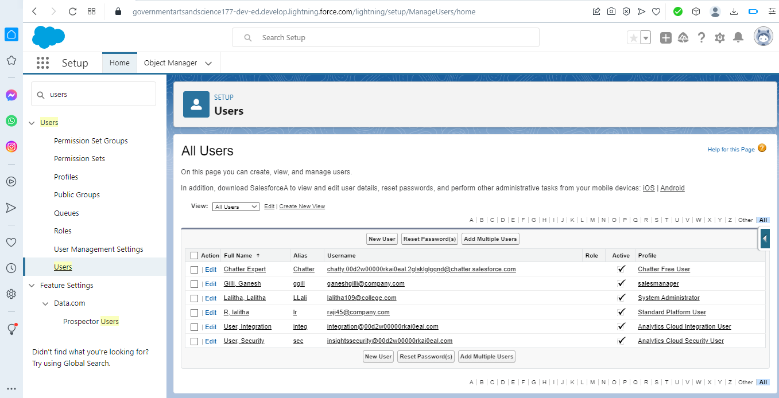

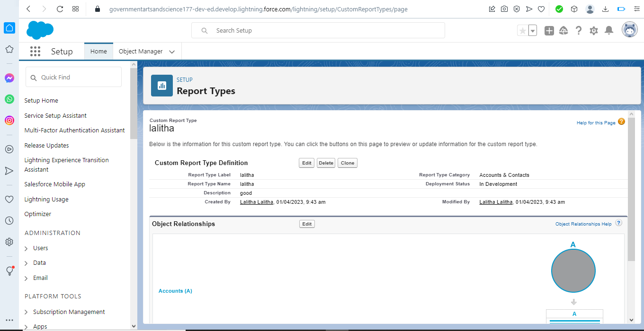

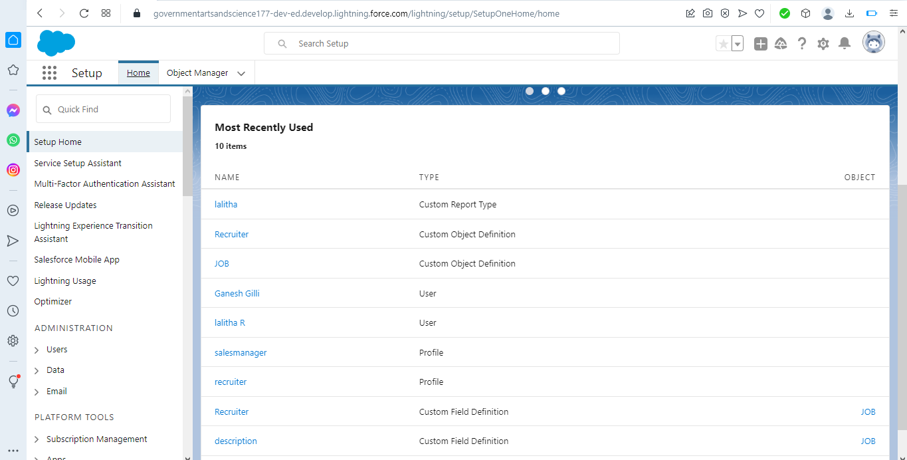

# TRAILHEAD PROFILE PUBLIC URL

# TEAM LEAD-trailblazer.me/id/lalitha10

# TEAM MEMBER-https://trailblazer.me/id/murugesh932003

# TEAM MEMBER:-https://trailblazer.me/id/ramar2002M

# TEAM MEMBER-https://trailblazer.me/id/alagu77

# ADVANTAGES&DISADVANTAGES:

**7 Advantages of Using Applicant Tracking System**

* 1. Reduces time spent with administrative tasks An ATS software allows you to speed up your recruitment process and save yourself a huge amount of time for more important tasks. ...
* 2. Provides Better and Faster CV Screening ...
* 3. Facilitates Collaborative Hiring ...
* 4. Improves the Quality of Hire ...
* 5. Speeds up the Recruitment Cycle ...
* 6. Boosts Employer Brand ...
* 7. Enhances Candidate Experience

# DISADVANTAGE:

Technology resistant workforce

One of the obstacles you might need to overcome when introducing an ATS to your business is pushback from your colleagues. Some might not be adept with using technology, others might just be resistant to change.

This is why it’s important that if you do decide to invest in an ATS to ensure that your technology is as user-friendly as possible. You should also consider the levels of support and training that your potential suppliers offer when making your decision.

(For more tips on encouraging your workforce to use your ATS, download our free eBook: Engaging Hiring Managers with Recruitment Technology)

Additional cost

Picking up an additional expense is never ideal and most Applicant Tracking Systems will cost money, unless you are looking for a simple shortlist manager.

# APPLICATIONS:

SALES FORCE

GITHUB

# CONCLUTION:

An [Applicant Tracking System](https://www.jobscan.co/blog/what-is-an-applicant-tracking-system/) or ATS is an all-in-one human resource software that automates the hiring process, helps HR teams efficiently manage every part of recruitment (from job posting to onboarding), and solves recruiters’ challenges and pain points.

Specifically, the ATS:

* Stores job candidate information like resumes, cover letters, references, and other recruitment and hiring data that HR teams can easily access and organize.
* Tracks job candidates and their application status throughout the hiring pipeline.
* Weeds out unqualified candidates and recommends the best fit for a position based on the parameters set by HR. Only those on the shortlist are moved to the next stage of the hiring process.
* Automates time-consuming administrative tasks such as manually screening applicants, reading resumes, scheduling interviews, and sending notifications and emails to job candidates and employees.

# FUTURE SCOPE:

*The applicant tracking system (ATS) software market is projected to experience significant growth in the coming years. The market is segmented by deployment type, organis*Applicant tracking system (ATS) is software that simplifies the recruiting process by organising candidates with automated intelligence. This helps the recruiters screen the most and best-qualified candidates based on collected information regarding experience, skillset, and other aspects.

Applicant tracking systems have a vast market, with more than **[90% of Fortune 500 companies](https://medium.com/swlh/90-of-fortune-500-companies-use-an-applicant-tracking-system-whats-it-5a6b6d25e5e7" \t "https://gohire.io/blog/_blank)** using the software. It was valued at 2.3 billion US dollars in 2021 and will be approximately 3.2 billion US dollars in the next five year.

|  |
| --- |
| TEAM MEMBER-https://tailblazer.me/id/alagu77 |
|  |
|  |
|  |
|  |
|  |
| Screenshot (5) |
|  |
|  |
|  |
|  |
|  |
|  |
|  |
|  |
|  |
|  |
|  |
|  |
|  |
|  |
|  |
|  |
|  |
|  |
|  |
|  |
|  |
|  |
|  |
|  |

|  |
| --- |
|  |